Assessment : Rohit Durai

Pseudo code 10 Marks

**Q1 : Write a Pseudo code for verify if number entered is prime number**.

Begin

Read the number from user and store it as n  
Declare IsPrime flag

If n = 0 or n=1 then Display (“Number is NOT Prime”)

Else

For x = 2 to n-1 do,

Begin Block

If n is divisible by x then set IsPrime = False

End Block

If IsPrime = TRUE then Display (“Number is Prime”)

Else Display (“Number is NOT Prime”)

End

**Q2: Write a Pseudo code for transferring amount from one account to another. [Should validate whether both accounts exists]**

Begin

Read Debit Account, Credit Account, and Amount from user as A1, A2 and Amt

Validate A1 with Debit bank Database

Validate A2 with Credit bank Database

If A1 is Active and Amount in A1 > Amt

Then

Check If A2 is Active

Then transfer Amt from A1 to A2 and update Balance in A1 and A2

Print (“Account Transfer complete”)

Else Print (“Credit Account is Invalid”)

Else Print (“Debit Account is Invalid”)

End

RDBMS: 30 Marks

**Q1. Write SQL Query to create following tables [DO NOT CREATE PRIMARY / FOREIGN KEYS ]**

Customer: CustomerId, Fullname, address, city, pan number

Account: accountNo, accType, balance, customerId

Create TABLE Customer (

CustomerId varchar2(20)not null ,

Fullname varchar2(20)not null,

Address varchar2(60)not null,

City varchar2 (20)not null,

pannumber varchar2(10)not null

);

Create TABLE Account (

accountNo varchar2(20) not null,

accType varchar2(20) not null,

balance number(10,2) not null,

customerId varchar2(10) not null

);

**Q2. Write SQL to insert following records in Customer & Account tables:**

|  |  |  |  |  |
| --- | --- | --- | --- | --- |
| C1002 | Rajiv Bhatia | Xyz Path, Chandni chowk | Delhi | AXNSS 1234 A |
| C1003 | Alia Bhatt | Khar | Mumbai | SZAXS 5656 B |
| C1004 | Vijay Deol | Bandra | Mumbai | APOI 5675 A |
| C1005 | Ajay Deol | Bandra | Mumbai | AUIO 7676 K |

Insert into Customer (CustomerId, Fullname, Address, City, pannumber)Values ('C1002', 'Rajiv Bhatia', 'Xyz Path Chandni chowk', 'Delhi', 'AXNXX1234A');

Insert into Customer (CustomerId, Fullname, Address, City, pannumber)Values ('C1003', 'Alia Bhatt', 'Khar', 'Mumbai', 'SZAXS5656B');

Insert into Customer (CustomerId, Fullname, Address, City, pannumber)Values ('C1004', 'Vijay Deol', 'Bandra', 'Mumbai', 'APOI5675A');

Insert into Customer (CustomerId, Fullname, Address, City, pannumber)Values ('C1005', 'Ajay Deol', 'Bandra', 'Mumbai', 'AUIO7676K');

|  |  |  |  |
| --- | --- | --- | --- |
| SB122666 | Savings | 67000 | C1002 |
| CB565556 | Current | 786928.98 | C1002 |
| SB876565 | Savings | 547899.90 | C1004 |
| SB565722 | Savings | 67600 | C1003 |
| SB757676 | Savings | 66197.88 | C1003 |
| SB166778 | Current | 16000 | C1008 |

Insert into Account (accountNo, accType, balance, customerId) Values ('SB122666', 'Savings', '67000', 'C1002');

Insert into Account (accountNo, accType, balance, customerId) Values ('CB565556', 'Current', '786928.98', 'C1002');

Insert into Account (accountNo, accType, balance, customerId) Values ('SB876565', 'Savings', '547899.90', 'C1004');

Insert into Account (accountNo, accType, balance, customerId) Values ('SB565722', 'Savings', '67600', 'C1003');

Insert into Account (accountNo, accType, balance, customerId) Values ('SB757676', 'Savings', '66197.88', 'C1003');

Insert into Account (accountNo, accType, balance, customerId) Values ('SB166778', 'Current', '16000', 'C1008');

**Q3. Write a Left Join to get all customers and accounts. Join should display all customers [Even those who DO NOT have any account].**

Select * from Customer LEFT JOIN Account using (customerid);

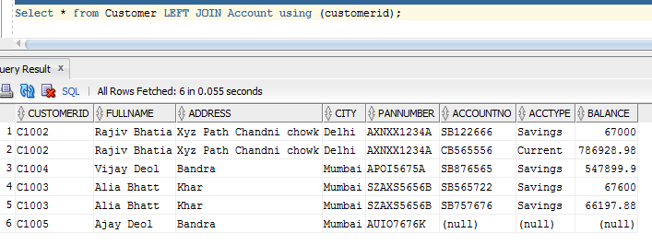

UML 10 Marks

**Q1. For RDBMS Question #1, Create Class Diagram for Both tables.**

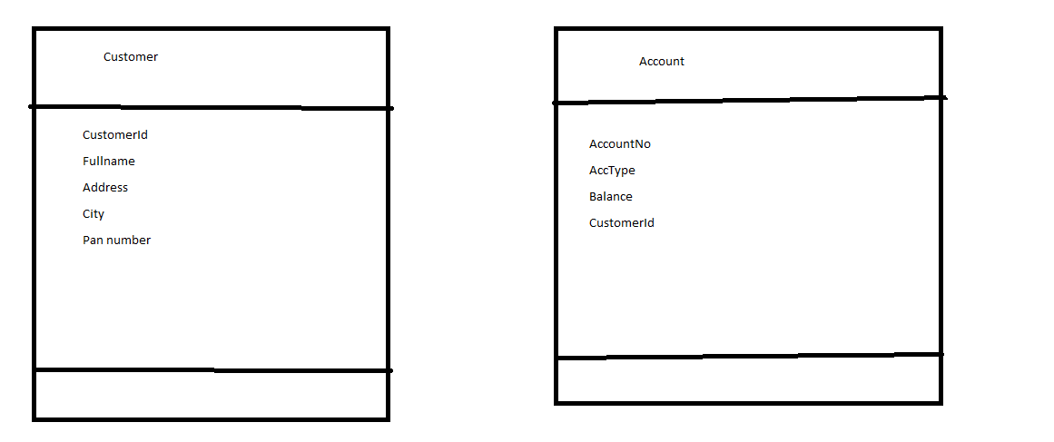

**Q2. Create an Activity Diagram to explain fund transfer.**

HINT: Fund transfer is possible from Any account type to any other account type.

Must validate existence of both account

Must validate account balance before transfer

Must update balance after transaction completes.

